

Venue User Guide
for the


Mobile Device Charging Station

Product | Charge Daddy Venue User Guide
Version | 1.d

Venue User Guide

November 2013

IF YOU EVER HAVE ANY PROBLEMS WITH YOUR CHARGE DADDY SYSTEM THAT CAN NOT BE SOLVED BY THE STEPS OUTLINED IN THIS DOCUMENT. PLEASE CONTACT THE SERVICE CENTER IMMEDIATELY AT 877-592-0985. OUR NORMAL OPERATING HOURS ARE 9:00 AM-6:00 PM (EASTERN). AFTER HOURS, AN ON CALL SERVICE IS AVAILABLE 24 HOURS. ALL MESSAGES WILL BE RESPONDED TO BY THE NEXT BUSINESS DAY.

NEVER TURN THE CHARGE DADDY OFF OR DISCONNECT IT FROM THE INTERNET. THE SYSTEM MUST HAVE POWER AND AN INTERNET CONNECTION IN ORDER FOR US TO ASSIST YOU WITH IMMEDIATE SERVICE WHEN YOU CALL.

Document Revision History

Tiburon Lockers, Inc.
Title: | Charge Daddy Venue User Guide
Date | Revision | Author | Description
04/15/2013 | 1.a | NDP | First Pre-Release of Documentation
5/31/2013 | 1.b | NDP | Updated device name
8/20/2013 | 1.c | NDP | Updates to process and images
11/19/2013 | 1.d | NDP | Corrections to Grammar

Table of Contents

1. Introduction 5
2. Prerequisites 5
3. Customer Usage 5
3.1. Renting a Compartment 5
3.2. Opening a Compartment 7
3.3. Checking Out of a Compartment 8
4. Venue Usage 9
4.1. Accessing the Administrative Area 9
4.2. Logging into the Administrative Area 10
4.3. Administrative Functions 10
4.3.1. Actions 10
5. Power-down Procedure 11
6. Cleaning a compartment 11
7. FAQ 12
7.1. Troubleshooting 12
7.1.1. Customer cannot access their compartment 12
7.1.2. System is not accepting credit card transactions 12
7.1.3. The compartments LED’s are not on 12
7.1.4. PC is unresponsive, appears to be frozen 12
7.1.5. System appears to be off 13
7.2. Q & A 13
7.2.1. What happens if a customer forgets their compartment number? 13
7.2.2. What if a customer’s credit card is forgotten / lost? 13
7.2.3. What if a customer claims their device isn’t or didn’t charge? 14
7.2.4. What do the different color LED’s mean? 14
7.2.5. What keys are provided with the Charge Daddy system? 14
7.2.6. How do I open a compartment if the power is off or the computer has failed? 14
7.2.7. How many users can have access to the Administrative Area of the system? 14
7.2.8. What should we do if the system ever causes an injury? 14
7.2.9. What should we do if there is inclement weather and/or severe damage to the Charge Daddy? 15

Introduction
This document explains how to operate the Tiburon Charge Daddy charging station by the end user and the venue staff.

Prerequisites
  - Charge Daddy System has been installed at venue and is operational.
  - Venue Users have been trained.
  - Venue Users have been provided admin login access codes.
  - Venue Users have been provided unique personal access codes to log into the system.

Customer Usage
The following examples show you screen by screen, each step a customer would take to rent a compartment, open their compartment and checkout of their compartment.

Renting a Compartment

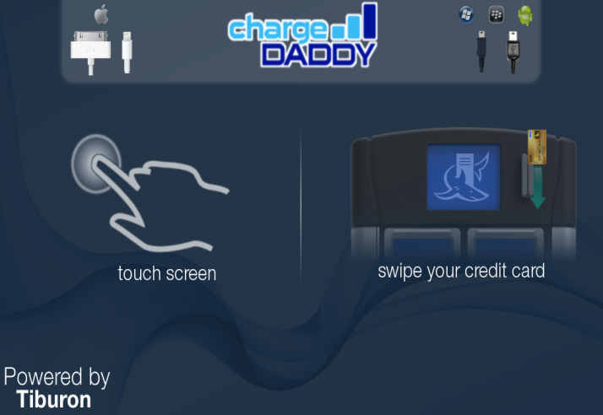

Screen 1: The default screen asks a customer
to touch screen or swipe credit
card.

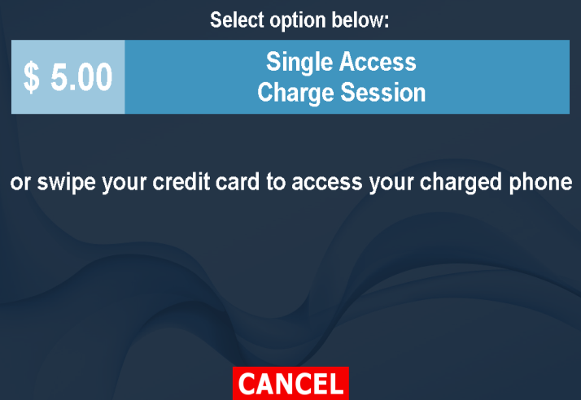

Screen 2: Asks the customer to make a
selection.

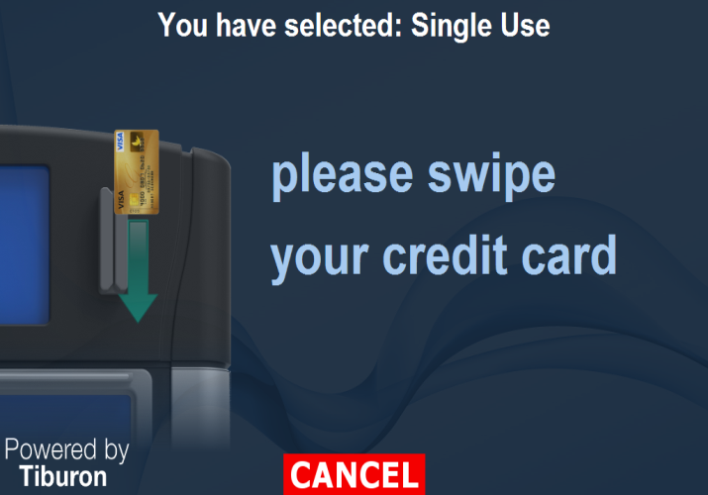

Screen 3: Asks the customer to swipe credit card.

(Note: This screen will not appear if card was
swiped on screen 1.)

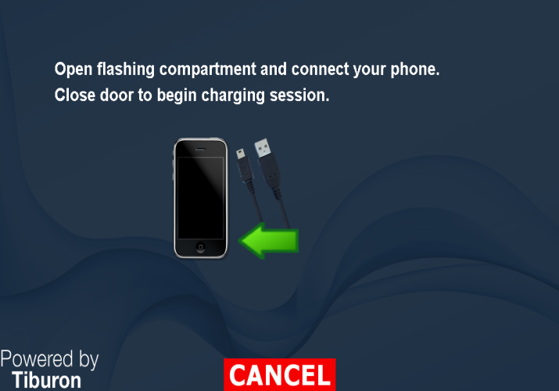

Screen 4: Asks the customer to open the
compartment that is flashing and
plug in device. Door will lock
once it’s closed.

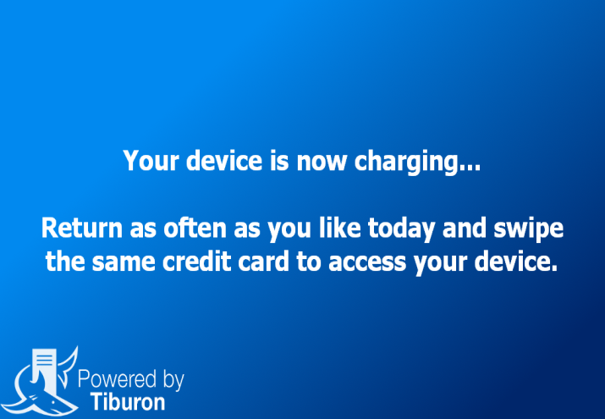
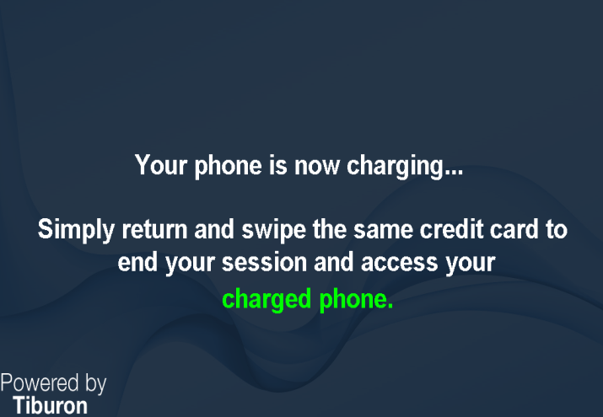

Single Access Charge Session VIP All Day Access

Screen 5: Informs the customer their device is charging. Customer can access their compartment by swiping
the same credit card used for rental.

Opening a Compartment


Screen 1: If a customer paid for a VIP All Day
Access then they will be able to
swipe their card and access their
compartment as often as desired.

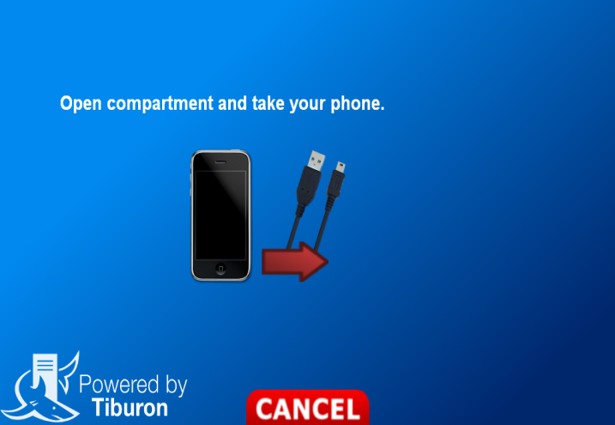

Screen 2: Tells the customer their door is
unlocked. Customer may return at
anytime during the same day and use
their compartment.

(Note: Compartment will remain ‘rented’ until
the end of the day, 12:00 am.)

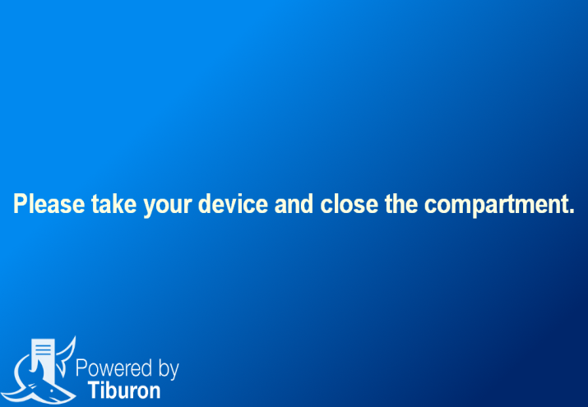

Screen 3: After the door has been opened the
next screen tells the customer to take
their device and close the
compartment door.

(Note: If at this point the customer decides to
leave their device charging they will need to
swipe their card again to turn the charging back
on.)

Checking Out of a Compartment


Screen 1: On default screen, customer
swipes their credit card to access
their compartment.

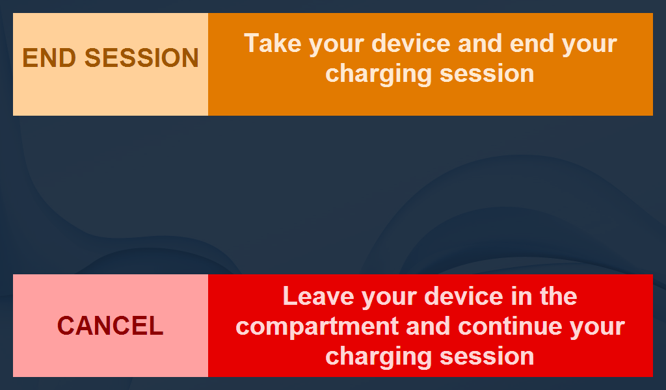

Screen 2: Customer is asked to confirm
they wish to end their rental by
selecting ‘END SESSION’, if user
selects ‘CANCEL’ the door will
not unlock and their rental will
continue.

(Note: Checkout function only for ‘Single
Access’.)

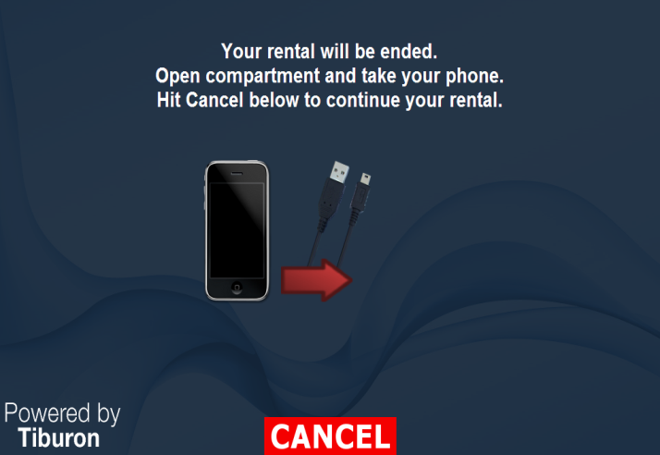

Screen 3: Lets the customer know the door to
their compartment is unlocked.
Once customer opens door the
rental is over and they can no longer
access the compartment. If
‘CANCEL’ is selected then door will
relock.

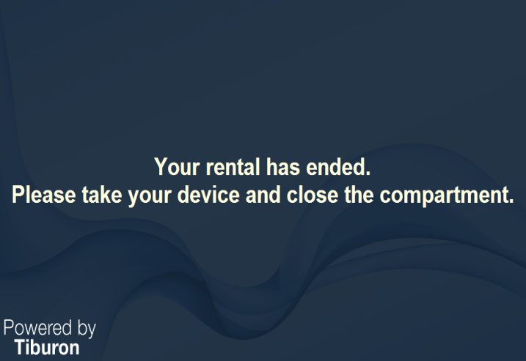

Screen 4: After the door has been opened the
next screen lets the customer know
that their rental has ended. Customer
needs to remove their device and
close the compartment.

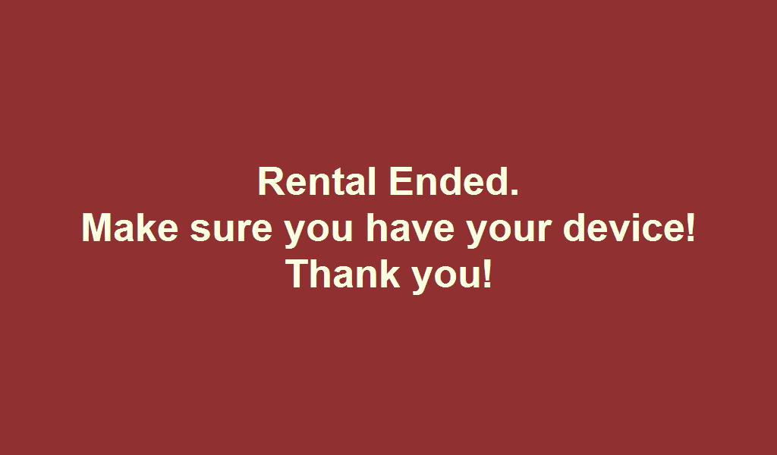

Screen 5: After door is closed the last screen
reminds the customer to make sure
they have their device and thanks
them.

Venue Usage

Accessing the Administrative Area
Touch the default screen of the Charge Daddy to proceed to the next screen, enter the “Screen corner code” provided by Tiburon. The image below shows the 4 areas of the screen and the numbering of those areas. Each venue will have a unique sequence. After the “Screen corner code” has been entered the next screen will appear which will have a keypad for Administrator to enter their personal “Admin code”. For example: if the “Screen corner code” is 12341, you would touch the top left corner, the top right corner, the bottom right corner, the bottom left corner and finally the top left corner (clockwise), the Admin login screen would then appear.
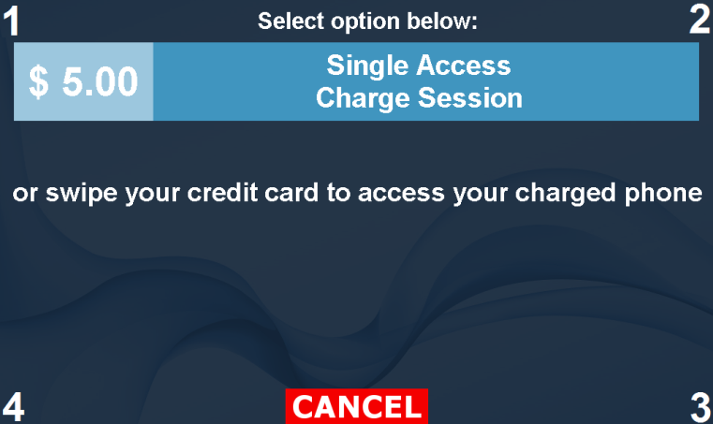

Entering code for access to Admin login

Logging into the Administrative Area
After gaining access to the login area you will enter your personal “Admin code” into the keypad and select the “Enter” key, access will be granted if entered correctly. For example, if your personal “Admin code” is 3232 you would type 3232 using the keypad and then you would select the enter key. (Refer to 4.1)
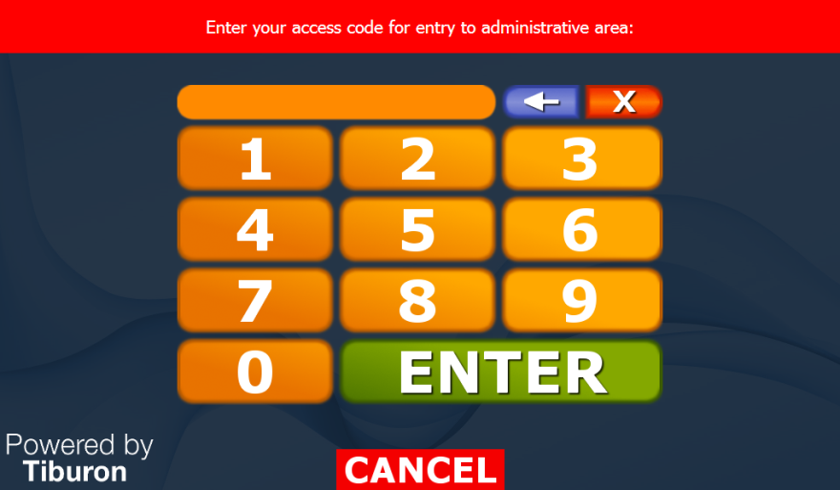

Personal Admin Code + ENTER

Administrative Functions
This area is designed to grant the venue the ability to perform certain functions on the Charge Daddy system, the menu that is displayed is unique to a user’s personal login and their specific role as setup within the system. All administrative functions are accessed via the Admin Selection Screen. The necessary actions are explained further below:
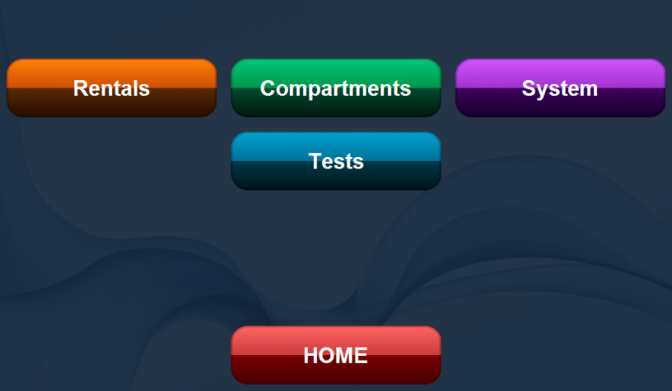

Admin Selection Screen

Actions
Rentals – Displays an additional selection screen for the Administrator to make a selection. The options are ‘End Rental’, ‘Cancel Rental’ and ‘Reassign Rental’. For each of the three options a graphical display of the compartments is shown and the Administrator needs only to select the compartment to perform action.
  - ‘End Rental’ should be selected when it is known that the end user is finished with the compartment for the day, allowing the reserved compartment to be returned to the ‘available pool’ of compartments for others to use.
  - ‘Cancel rental’ should be selected when an Administrator wants to terminate the transaction and allow the reserved compartment to be returned the “available pool”.
  - ‘Reassign Rental’ should be selected if an end user is having complications accessing the compartment originally assigned.
Compartments – Displays an additional selection screen for the Administrator to make a selection. The options are ‘Open’, ‘Cleaning’, ‘Enable/Disable’ and ‘Status Report’.
- 'Open' would be used when an Administrator wanted to open a compartment.
- 'Cleaning' would be used when an Administrator wants to clean a compartment.
- 'Enable/Disable' would be used when an Administrator wants to disable or enable a compartment.
- 'Status report' currently this function is not available yet and is intended for future feature expansion.
System – Displays an additional selection screen for an Administrator to make a selection. The options are ‘Restart System’, ‘Quit Application’, and ‘Shutdown System’.
- ‘Restart System’ should be selected when an Administrator wants to reboot/restart the tablet pc.
- ‘Quit Application’ would be used when an Administrator has been instructed to turn off the application.
- ‘Shutdown System’ is used when an Administrator wants to shut down the tablet pc.

Cleaning a compartment
Generally, a damp cloth or paper towel is sufficient to clean wipe a compartment clean. If necessary, a mild all-purpose cleanser may also be used. The following steps should be taken to manually open a compartment for cleaning:
- Login to the Admin Selection Screen as outlined above.
- Select the ‘Compartments’ button.
- Select the ‘Cleaning’ option.
- Select the compartment to be cleaned.

Power-down Procedure
The following steps should be taken to power the system down – before power is removed from the Charge Daddy system:
- Login to the Admin Selection Screen as outlined above.
- Select the ‘System’ button.
- Select the ‘Shutdown System’ option.
- The Charge Daddy will automatically shut down and power itself off. NOTE: If for some reason the Charge Daddy does not appear to shut down, then the Administrator should select the ‘Quit Application’ option and then from the windows desktop screen select “Start/Shutdown” and manually shut the host system off.

Note: It is important that customers not be given access to this sensitive area, therefore Administrators should be trained to log out of the Administrative Area as soon as their operations are complete. Do not walk away from system while Administrative Area is accessible. Touch the Home button at the bottom of the screen to return to the main screen.

FAQ
The following section is intended to help you to assist your customers on a daily basis. It contains some basic troubleshooting steps and answers to some frequently asked questions that you may encounter.

Troubleshooting

Customer cannot access their compartment
- Is there power to the PC?
  - Yes, power is visible on the PC, proceed to the next step.
  - No, power is not visible on the PC, proceed to step 5.1.5.
- Review the status report, verify that compartment in question is rented and is not denied access.
  - If compartment does not show as rented proceed to the step D.
  - If compartment is rented but access is denied, verify with management before allowing access.
  - If compartment is rented and access is not denied, proceed to the next step.
- Verify, by following the same steps as customer (swipe customer’s credit card).
- Determine if compartment can be opened using the open compartment function.
  - If so, have patron verify belongings.
  - If not call Tiburon Customer Service and continue to next step.
- Open compartment using manual override key, have patron verify belongings.

System is not accepting credit card transactions
- Has a rental been attempted with a different credit card?
- If yes and second card was also rejected, proceed to next step.
- If no, attempt a rental with a different card, if unsuccessful proceed to next step.
- Call Tiburon Customer Service, to walk through additional steps.

The compartments LED’s are not on
- Is there power to the PC?
- Yes, power is visible on the PC, proceed to next step.
- No, power is not visible on the PC, proceed to step 5.1.5.
- Do compartments respond when a command is sent?
- If yes, proceed to next step.
- If no, STOP! Call Tiburon Customer Service, system is out of order and a technician will be scheduled to service the system.
- Do LED’s respond when a command is sent?
- If yes, do LED’s stay on? If no, follow instructions for II.
- If no, call Tiburon Customer Service, technician will be scheduled to service the system.

PC is unresponsive, appears to be frozen
- Restart system by setting switch on power strip to off, wait 5 seconds then switch back on.
**Reboot should take place within 15 seconds after plugging back in**
- Contact Tiburon Customer Service if problem still persists.

System appears to be off
- Is there power to the PC?
- Yes, power is visible on the PC, proceed to next step.
- No, power is not visible on the PC, proceed to step C.
- Is there power to the compartments? (The compartment’s will be lit up)
- Yes, compartments have power but PC does not. Proceed to step F.
- No, some or all of the compartments do not have power. Partial communication failure between the PC and the compartments.
  - Verify what compartments are still functional in the system and disable any that are malfunctioning.
  - System is functional but a field visit from Tiburon is required to correct the problem.
- Verify the system is plugged into the power strip and that the power strip is on.
- If yes, proceed to next step.
- If no, plug in and using the manual override key open access panel and push red power button; system should power up.
- Verify line cord is plugged into the back of the system. Proceed to next step.
- Restart system by setting switch on power strip to off, wait 5 seconds then switch back on and using the manual override key open access panel and push red power button; system should power up.
- Yes, system is fully functional.
- Yes, compartments have power but PC does not. STOP! Call Tiburon customer service, a technician will be scheduled to service the system.
- No, some or all of the compartments do not have power. Partial communication failure between the PC and the compartments.
  - Verify compartments that are still functional and disable any that are malfunctioning.
  - System is still functional but a field visit from Tiburon is required.
- No, both the compartments and PC do not have power. Power is out to the entire system.
  - Verify that the system is plugged into the corresponding outlet, if accessible and said outlet is receiving power.
    - Using manual override key open access panel and push red power button. If the system does not power up, STOP! Call Tiburon customer service, a technician will be scheduled to service the system.

Q & A

What happens if a customer forgets their compartment number?
No worries! A customer doesn’t need to remember their compartment number. Have customer swipe their credit card that was used during rental, system will unlock the appropriate compartment.

What if a customer’s credit card is forgotten / lost?
The following steps should be taken to manually open a compartment to retrieve a user’s phone:
  - Login to the Admin Selection Screen as outlined above.
  - Select the ‘Compartments’ button.
  - Select the ‘Open’ option.
  - Select the compartment containing the end-user’s phone. NOTE: Great care should be taken to verify the identity of the end-user to ensure it is their phone.
  - If the end-user is, in-fact leaving with their device (not going to continue their charge session), then the Administrator should also end the renal so the compartment is then freed for the Charge Daddy to allow someone else to use the compartment.

What if a customer claims their device isn’t or didn’t charge?
If rental is still active the venue can choose to either reassign the rental or cancel the rental. If the rental has already been ended the customer has already been charged, STOP! Call Tiburon customer service to go over further options.

What do the different color LED’s mean?
The state of the compartment will dictate which color LED is active. For example, if a compartment is available the active LED will be BLUE. If a compartment is rented ‘charging’ then there will be no active LED (off) and when device is fully charged, active LED will be green. Last, if a compartment’s door is open the active LED will be white.

What keys are provided with the Charge Daddy system?
The venue is given (2) keys for the “Manual Override” located in the center of every access door and (2) keys for the “PC Power” located on the right upper side of the device.

How do I open a compartment if the power is off or the computer has failed?
To open a compartment manually, in the event of power failure or if the computer has failed, use the key provided for the manual override cam lock. The four compartments associated with that access door will then be accessible. It is recommended that additional security steps be taken to ensure a patron’s device is not given to another.

How many users can have access to the Administrative Area of the system?
When your Charge Daddy is set up you will be asked who you would like to have access to the system. Please exercise discretion when making this decision. Access to the Administrative Area of the system should be as restricted as possible. Security and other after hour’s staff members may be granted access with very limited privileges. Please note that every user is assigned a personal PIN number. Individuals who access the system inappropriately may have their access revoked. Locations may also be charged for a service call if inappropriate user activity disables the system beyond Tiburon’s ability to make repairs remotely.

What should we do if the system ever causes an injury?
In the event that the Charge Daddy system causes an injury on site, staff should contact Tiburon immediately at 877-592-0985 or 201-750-4960. If the event is after hours please notify the answering service that you are reporting an injury. Management will be notified and will contact the venue.

What should we do if there is inclement weather and/or severe damage to the Charge Daddy?
In the event that the Charge Daddy system is severely damaged or may be potentially damaged by impending severe weather, please contact Tiburon customer service. Depending on location and if situation is warranted, Tiburon may need further assistance from the venue.

